MY ROOM

1. Kje so hišni ljubljenčki? S pomočjo slike dopolni povedi.
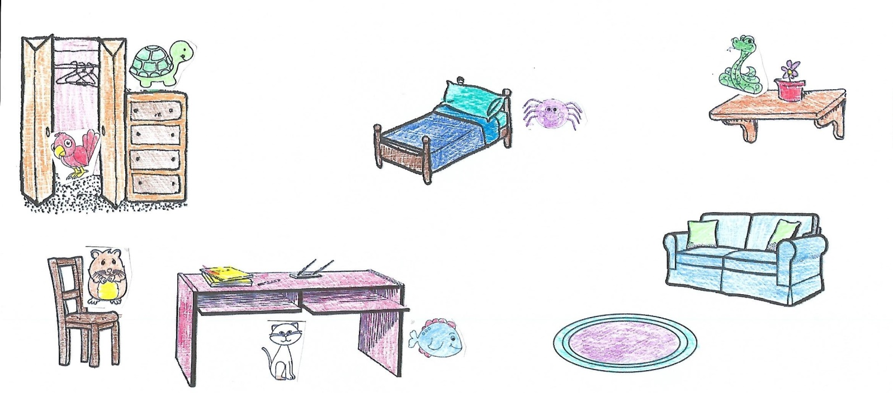
under next to snake desk hamster fish drawer shelf in

1. The __________ is next to the desk.
2. The ______________ is on a chair.
3. The turtle is on the ___________________.
4. The spider is ________________ the bed.
5. The _______________ is on the ___________________.
6. The cat is _______________ the ________________.
7. The bird is ______________ the wardrobe.

