|  |  |  |
| --- | --- | --- |
| 1. Dopolni dialog. Deček in deklica se sprašujeta o hobijih. | | |
| Rezultat iskanja slik za play guitar clipart black and white🗴 |  | Rezultat iskanja slik za drums black and white **🗸** |
| Rezultat iskanja slik za football clipart black and white **🗸** | Rezultat iskanja slik za tennis black and white **🗸** |
| Rezultat iskanja slik za painting clipart black and white 🗴 | Rezultat iskanja slik za ride a horse clipart black and white 🗴 |
| Rezultat iskanja slik za computer games black and white **🗸** | Rezultat iskanja slik za skateboard clipart black and white**🗸** |

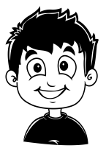 

1. ______ _________________________?

2. ________________________________?

3. ________________________________?

4. ________________________________?

1. ________________.

2. ________________ .

3. ________________.

4. ________________

1. No, I can’t.

2. Yes, ___________ .

3. ________________.

4. ________________

1. Can you _________________________?

2. ________________________________?

3. ________________________________?

4. ________________________________?