BODY PARTS
- Read the text and draw the picture of Horrible Mike.
Preberi besedilo in nariši sliko Groznega Mika.
This is Mike. He’s scary. He has got two long blue legs and six feet. On his orange body, he has got six blue arms and six hands. Each hand has got three fingers. He has got one big orange head. On his head he has got one small, round green eye and one big mouth with two long black teeth. He hasn’t got any nose or ears. He has got a ponytail on top of his head. He looks scary, but don’t worry, he is actually very nice.

- Read the text again and circle YES or NO.
Ponovno preberi besedilo in obkroži YES, če je trditev pravilna ali NO, če ni pravilna.
- Mike has got short legs. YES NO
- Mike is very nice. YES NO
- Mike has got blue eyes. YES NO
- His teeth are purple. YES NO
- Mike hasn’t got any hands. YES NO

- Look at the picture of Ben. Describe him. Write in sentences.
- Describe his look.
- Write down what is he like and how old is he (use your imagination).

Oglej si Bena. Opiši ga. Uporabi cele povedi.
- Opiši njegov izgled (barvo in dolžino las, barvo oči, brado, očala, velik nasmeh ...).
- Opiši kakšen je (je zabaven, vesel, žalosten, lep, grd …) in koliko je star (uporabi domišljijo).

This is Ben. He is my friend.

- Write down the names of the body parts. Don’t forget to write down articles a/an where necessary.
Zapiši imena delov telesa. Ne pozabi zapisati členov a/an kjer je to potrebno.

FOOD

- Ron has got a birthday party. At his party he and his friends eat all the food that is in the pictures. Look at the pictures and write down the names of the food that they eat at his party.
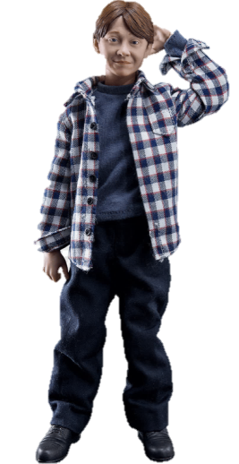
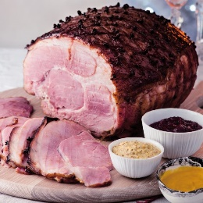
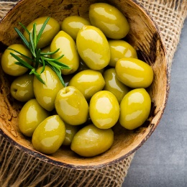
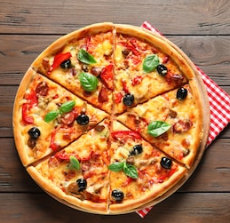
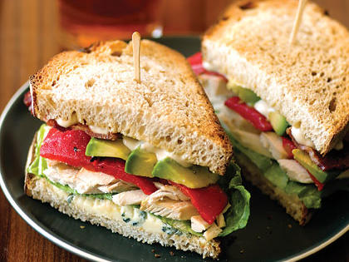
Ron ima rojstnodnevno zabavo. Na zabavi s prijatelji jedo hrano, ki je na slikah. Poglej si slike in zapiši imena hrane, katero jedo na zabavi.

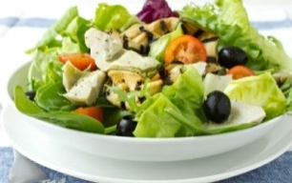
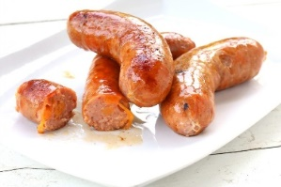
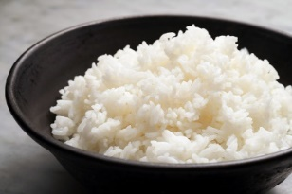

Look at all the food at Ron’s party! There are sandwiches.

- Read the text. Preberi besedilo.
Hello. My name is Anna. I usually have toast and jam for breakfast. I drink juice. Sometimes I also eat apples or plums. I like plums. I have got rice, chicken and some vegetables for lunch. I drink water. If mom prepares sausages, I don’t eat them. I don’t like sausages. I have pasta or pizza for dinner. If I am not hungry I eat a yoghurt.

Circle the sentences that are correct.
Obkroži odgovore, ki so pravilni.
- Anna eats toast and jam for breakfast.
- She doesn’t like plums.
- Anna eats an apple for dinner if she is not hungry.
- Anna drinks juice for breakfast.
- She likes plums.
- For dinner she eats rice.

- Write down which food you like and which food you don’t like as said in picture?
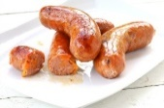
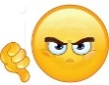
Zapiši katero hrano imaš rad/rada in katere ne maraš, glede na priložene slike.
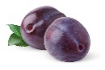
Anna: I like plums. I don’t like sausages.
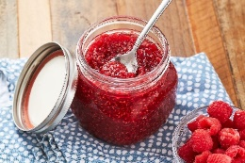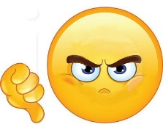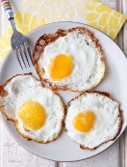
You:

- Write the text that is missing. Use your imagination. Use full sentences.
Zapiši besedilo, ki manjka. Uporabi domišljijo. Uporabljaj polne povedi.
R: Do you like yoghurt?
S: Yes, I do.
R: ______________________eggs?
S: No, __________. Yuck!
R: __________________________?
S: ___________________.
R: What do you have for dinner?
S: I have _______________________ for dinner.

R: What do you have for breakfast?
S: ____________________________________.

R: Which food you never have for lunch?
S: ____________________________________.

