RAZREDNA URA

Individualni video klici z učenci.

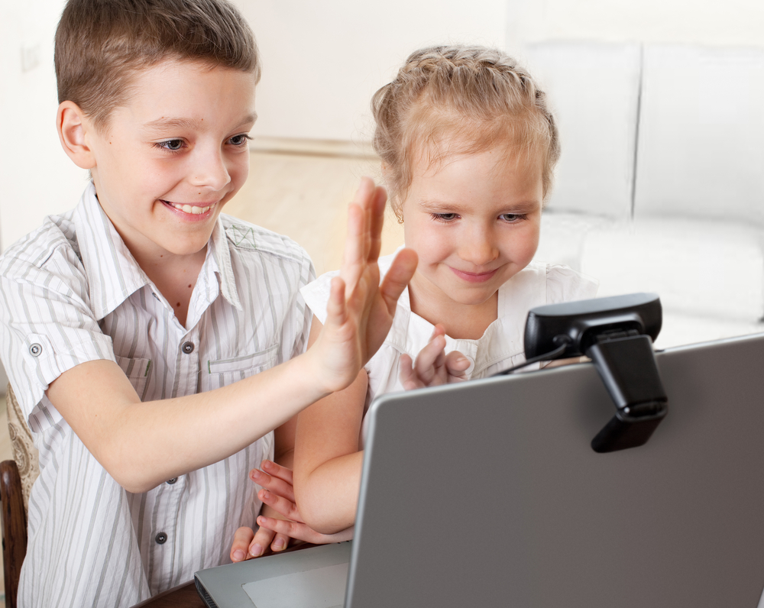
https://www.google.com/search?q=video+call+with+kids+classroom&tbm=isc

