8. razred, 2. in 3. skupina
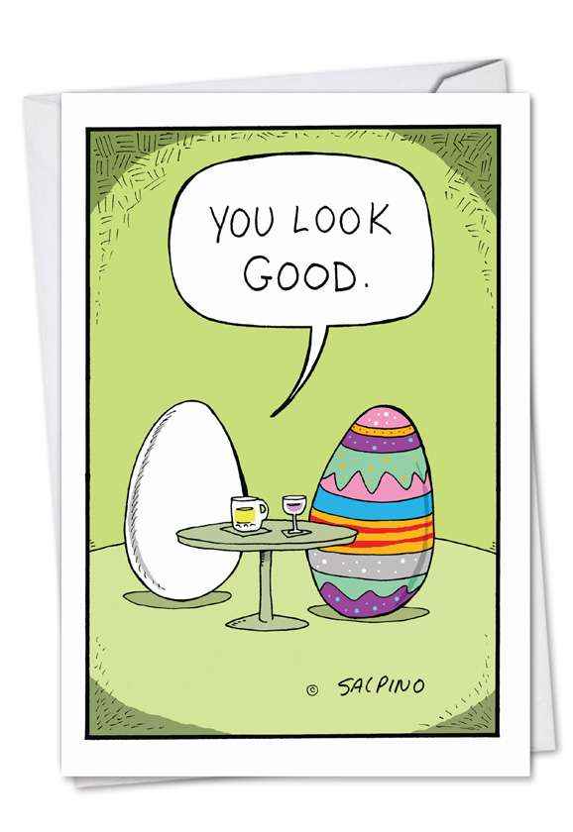
Monday, 6th April – Friday, 10th April

In this week, you will have the time to get familiar with some of the Slovene customs during Easter period:
Watch the clip first:
https://www.youtube.com/watch?v=s5Y52MRyfHs

What to do? You have two options (choose one):
- COLOUR SOME EGGS: I suggest that you watch the clip today and write down all the ingredients (of course you don’t have to colour 10 or 20 eggs, because that’s a lot, you can start with 3 or 5 – you will also need less onion peels) and think of how and when are you going to dye the eggs. Make a plan. Send pictures of the process and eggs to polona.zavrsnik@os-franaerjavca.si

- LEARN ABOUT ANOTHER EASTER CUSTOM: You can search the internet for another Slovenian Easter custom, read all about it and present it in a funny, innovative, creative way - you can make a mind map, poster, power point presentation, comic, etc. – be creative and use your imagination! Send your project to polona.zavrsnik@os-franaerjavca.si

Because I know that you all work hard and I wanted to show you that I miss you, I am sending you a link to a short video I made. Hope you like it!
https://youtu.be/wN650hlRiQ4

Your teacher Polona

