8. razred, 4. in 5. skupina, 20. 4. 2020 do 24. 4. 2020

Watch the video http://www.youtube.com/watch?v=WA3AiNup7fY and answer the questions.

Ötzi, the iceman

- When did the group of hikers come across a dehydrated human corpse?
- At which height was the body found?
- Was the body in a bad condition?
- Was this the body of a modern man?
- What did the researchers find next to him?
- How tall was this man?
- Why did the researcher give him the name Ötzi?
- Why did they find smoke in his lungs?
- What was placed strategically around his body?
- What gave the researchers the proof that this man was accustomed to manual labour?
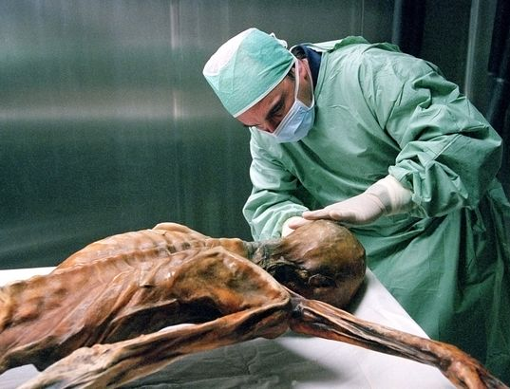
- From which material was the axe, which they found next to him, made?
- What was the bow covered with? Why (2 reasons)?
- What kind of kits did Ötzi have?
- Why did he have moss with him?
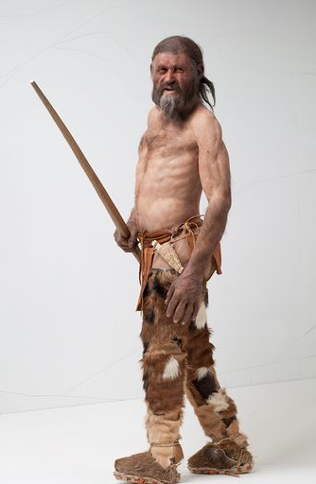
- What was special about his shoes?
- From which age were his clothes?
- What happened in 2001?
- Did Ötzi die of natural death? What exactly happened to him?
- Is Ötzi a secret?
- Why do people try to reconstruct the way he looked?
- Who has a tattoo of Ötzi? Where?
- What does Ötzi represent for the archaeologists?

Rešitve bodo objavljene ob koncu tedna.
Preverite rešitve nalog v delovnem zvezku str. 3 in str. 4 (naloga 1-3): https://www.mladinska.com/_files/32062/Project_4th_edition_Workbook_4_answer_key.pdf

V petek, 24. 4. 2020 se ob 11:15 dobimo, ker bomo imeli razredno uro, da se pogovorimo o ocenjevanju pri vseh predmetih.

Povezava: https://us02web.zoom.us/j/8214740748
ALI
Preko povezave https://zoom.us/join vtipkaš “Meeting ID” 8214740748.

