**FLYING DOCTORS**

Thomas James Ellis has a great story to tell about the day he was born. On 6th January 2004, Thomas was born several weeks early on a Flying Doctor **aircraft.** His parents live in the outback, a long way from any towns. “This is the third time the Flying Doctors have come to my **aid**. I don’t know what I would have done without them,” Thomas’s mother said.

The Flying Doctor service started in 1928. It was the idea of Reverend John Flynn, a church minister, who was working in the Australian outback. He had many stories to tell about how necessary an aerial medical service was, including one about Jimmy Darcy. Jimmy had a bad fall, and it took his friends twelve hours to take him thirty miles to the nearest town. The only person there who knew first aid was the Postmaster, and he performed a seven-hour operation without **anaesthetic**, following instructions in Morse code from his first aid teacher, who was 2,000 miles away. Unfortunately, Jimmy died ten days later.

In May 1928, Dr St Vincent Welch made the first official flying doctor visit. He had no radio, and used a compass and **landmarks** like rivers and fences to find his ways. Nowadays the Royal Flying Doctor Service has 46 planes, attends about 500 **patients** each day and services an area of 7,150,000 km2. Modern technology is also available: the doctors have digital cameras and video conferencing facilities. However, a pilot might still need the help of ordinary people on the ground when he is landing the plane in the **outback**: sometimes he asks them to do a ‘roo run’, which means driving up and down the landing area to frighten off kangaroos and other wild animals!

Even people who have never been to Australia have often heard of the Flying Doctors. In the 1980s a TV series was made about them, and shown in fifty countries. Also, next time you have an Australian $20 **banknote**, look more closely – the Flying Doctors and their founder, John Flynn, are on the ‘face’ of the note.

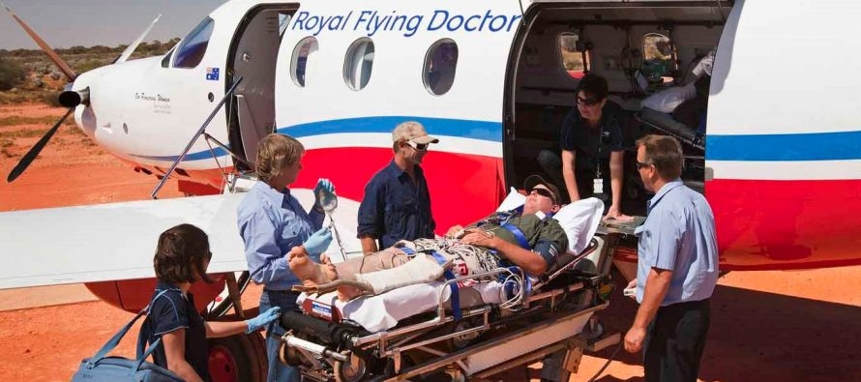

Osnovna šola Frana Erjavca Nova Gorica Šol. leto 2019/20

**2. PISNO OCENJEVANJE ZNANJA TJA**

Ime in priimek: _______________________________ Št. vseh točk: 50

Razred: 8. Št. doseženih točk: _________

Datum: 16. 3. 2020 Ocena: ___________________

**MEJE MED OCENAMI:**

|  |  |  |  |  |
| --- | --- | --- | --- | --- |
| 0–22 nzd (1) | 22,5–32 zd (2) | 32,5–39,5 db (3) | 40–44,5 pdb (4) | 45–50 odl (5) |
| 0−44 % | 45−64 % | 65−79 % | 80−89 % | 90−100 % |

|  |  |
| --- | --- |
|  | **5** |

**1. Read the text *Flying doctors* and mark the statements as true (T), false (F) or doesn’t it say (DS).** Preberi besedilo. Označi izjave kot pravilne (T), napačne (F) ali v besedilu ni podatka (DS).

|  |  |  |  |
| --- | --- | --- | --- |
|  | **T** | **F** | **DS** |
| 0. Thomas James Ellis worked on a Flying Doctor service on 6th January 2004. |  |  |  |
| 1. Thomas’s mother needed the help of the Flying Doctors more than twice. |  |  |  |
| 2. Phil Leroy was one of the first doctors who worked for the Flying Doctor service. |  |  |  |
| 3. Jimmy Darcy died during the operation without anaesthetic. |  |  |  |
| 4. The pilots sometimes ask people to help them in the landing area. |  |  |  |
| 5. John Flynn can be seen on Australian money. |  |  |  |

|  |  |
| --- | --- |
|  | **6** |

**2. Find the words in bold in the text *Flying Doctors*. Match them with the definitions.** V besedilu Flying Doctors poišči odebeljene besede. Poveži jih z razlagami.

|  |  |
| --- | --- |
| 0. *landmark* | A point in a landscape that is used as a reference or marks a boundary. |
| 1. | Paper notes which are used when we want to pay for something. |
| 2. | Isolated rural country especially of Australia. |
| 3. | A vehicle (such as an airplane or balloon) for traveling through the air. |
| 4. | Help or assistance that is given to someone in need. |
| 5. | A person or animal that is getting medical treatment. |
| 6. | Medicine that causes numbness in the body or loss of consciousness. |

|  |  |
| --- | --- |
|  | **3** |

**3. Imagine you are a doctor. On the basis of your patient’s symptoms define their health problems. Complete the table.** Predstavljaj si, da si zdravnik. Podane imaš simptome pacientov, na podlagi katerih moraš določiti zdravstveno težavo. Dopolni tabelo.

|  |  |
| --- | --- |
| **SYMPTOMS** | **HEALTH PROBLEM** |
| *pain in the ear* | *earache* |
| a burning hot forehead, shivers, a headache |  |
| a runny nose, a bad cough |  |
| a painful and scratchy feeling in my throat |  |

|  |  |
| --- | --- |
|  | **5** |

**4. Look at the pictures and write English expressions.** Oglej si slike in zapiši angleške izraze.

|  |  |  |
| --- | --- | --- |
|  |  |  |
| *a surgeon* |  |  |
|  |  |  |
|  |  |  |

|  |  |
| --- | --- |
|  | **5** |

**5. Underline the correct form.** Podčrtaj pravilno obliko.

**Example:** *My sister* ***has just won / won*** *an award for her voluntary work at the organisation Doctors Without Borders.*

1. I **have arranged / arranged** a dentist’s appointment two weeks ago.

2. He **has liked / liked** the TV show *The Good Doctor* since he was 10 years old.

3. I **have never saved / never saved** a person’s life, but doctors do that every day.

4. Jason **studied / has studied** medicine from 2012 to 2018**.**

5. **Have you watched / Did you watch** the documentary about health yesterday?

**6. A doctor working for the Flying Doctor Service is talking about his experience. Look at the chart. Form sentences about the things he has/hasn’t experienced so far.** Zdravnik, ki dela pri organizaciji Flying Doctors, govori o svojih izkušnjah. Poglej razpredelnico in tvori stavke, kaj je pri svojem delu že izkusil/česa še ni.

|  |  |
| --- | --- |
| *attack by a wild animal* | *NO* |
| see a patient die | YES |
| help at child birth | NO |
| treat a patient bitten by a snake | YES |

|  |  |
| --- | --- |
|  | **3** |



**Example:** *____He hasn’t been attacked by a wild animal.______________*

_____________________________________________________________

_____________________________________________________________

__________________________________________________________________

|  |  |
| --- | --- |
|  | **5** |

**7. Complete the sentences with the right form of the verbs in brackets.** Stavke dopolni z ustrezno obliko glagolov.

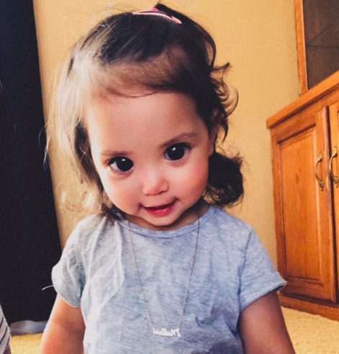Mehlani __*is*___ (**be**) a little [toddler with big, beautiful eyes](https://www.buzzfeednews.com/article/laurenstrapagiel/girl-axenfeld-rieger-syndrome-big-eyes). Mehlani _________________ (**live**) in Minnesota with her mom, Karina Martinez. The doctors ________________________ (**diagnose**) the little girl with [Axenfeld-Rieger syndrome](https://ghr.nlm.nih.gov/condition/axenfeld-rieger-syndrome) in 2015.

Martinez ____________________ (**tweet**) about her daughter's condition in December 2019, and the tweets went viral. She says that she _____________________________ (**receive**) so many comments and positive messages since then. “People are super nice” she told The News Feed. At the moment, Mehlani and her mom ___________________________ (**write**) an answer to one of their internet friends.

|  |  |
| --- | --- |
|  | **3** |

**8. At the hospital, there are some rules that you must respect. Look at the signs and explain what you must/mustn’t do.** V bolnišnici so določena pravila, ki jih moramo upoštevati. Oglej si znake in zapiši, kaj moramo in česa ne smemo početi.

0 .1. 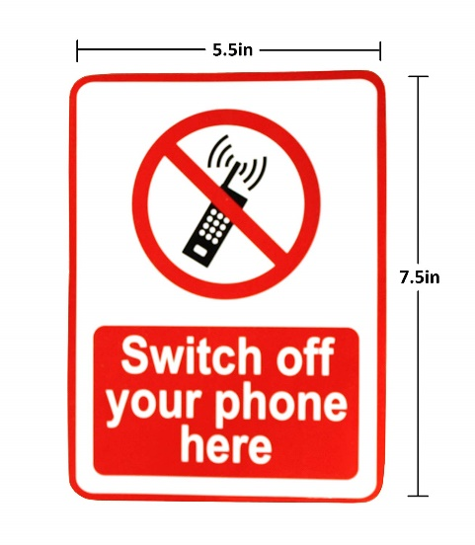2. 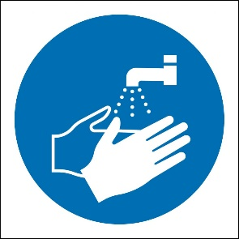3. 

**Example:** *0.* **_______***You mustn’t be loud._______________________________________*

**1.** _________________________________________________________________________

**2.** _________________________________________________________________________

**3.** _________________________________________________________________________

|  |  |
| --- | --- |
|  | **3** |

**9. Match the questions with the answers.** Vprašanja poveži z odgovori.

|  |  |  |  |
| --- | --- | --- | --- |
| **0.** | *What’s the matter, Paul?* |  | Hmmm… I’ve had it for about a week. |
| **1.** | How long have you had the rash for? |  | No, not that I know of. But I have been eating more nuts lately. |
| **2.** | Do you have any other symptoms besides the rash? |  | Yes, I’ve put some cream on it and I’ve taken a painkiller. |
| **3.** | Have you eaten something that was bad? |  | Yesterday. |
| **4.** | Ok, I think you probably have food allergy. Have you ever had any tests performed? | *0.* | *I have a rash on my arm. It’s quite big and red.* |
| **5.** | Have you taken any medicine for the rash already? |  | No, I haven’t. |
| **6.** | When did you take the painkiller? |  | Yes, I also have spots on my chest and yesterday I felt sick. |

|  |  |
| --- | --- |
|  | **7** |

**10. Read the text and put the verbs in brackets into the correct form.**

Sheila Wilson _*is__* (be) a doctor. She works in Belgium, but this year she ________________________ (**work**) in Africa. So far she ____________________________ (**be**) to nearly every country in the world, but the most exciting time she ____________________________ (**ever / have**) was when she _______________________ (**go**) to the Amazon jungle in 2017 to help and treat ill people there. In September 2019 an African medical organisation called *CongoDocs* _________________________ (**offer**) her a job in a small village in the middle of nowhere. Sheila said yes and flew to Congo, Africa.

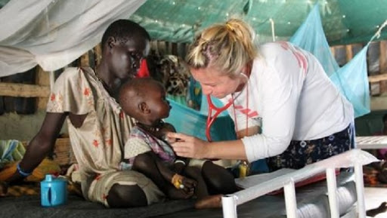At the moment Sheila _____________________________ (**perform**) an examination on a child with respiratory problems.

Since September Sheila _______________________________(**help**) more than 100 people get better.

**11. Imagine you are the health minister of Slovenia. You give advice on what students in schools should (3) and shouldn’t do (3) because of the coronavirus. Write whole sentences.** Predstavljaj si, da si minister za zdravje v Sloveniji. Učencem svetuješ, kaj bi morali (3) in česa ne bi smeli početi (3) zaradi koronavirusa. Piši v povedih.

|  |  |
| --- | --- |
|  | **5** |

