9. 3. in 4. skupina
WEDNESDAY, 25th March
Good morning to you all,
It’s Wednesday and we are starting with our fourth on-line English lesson.
Before we dig into our lesson today, I would like you to click on the link below: https://padlet.com/polonazavrsnik/20tdnz4ukio9
You will get to a webpage that should look something like that: 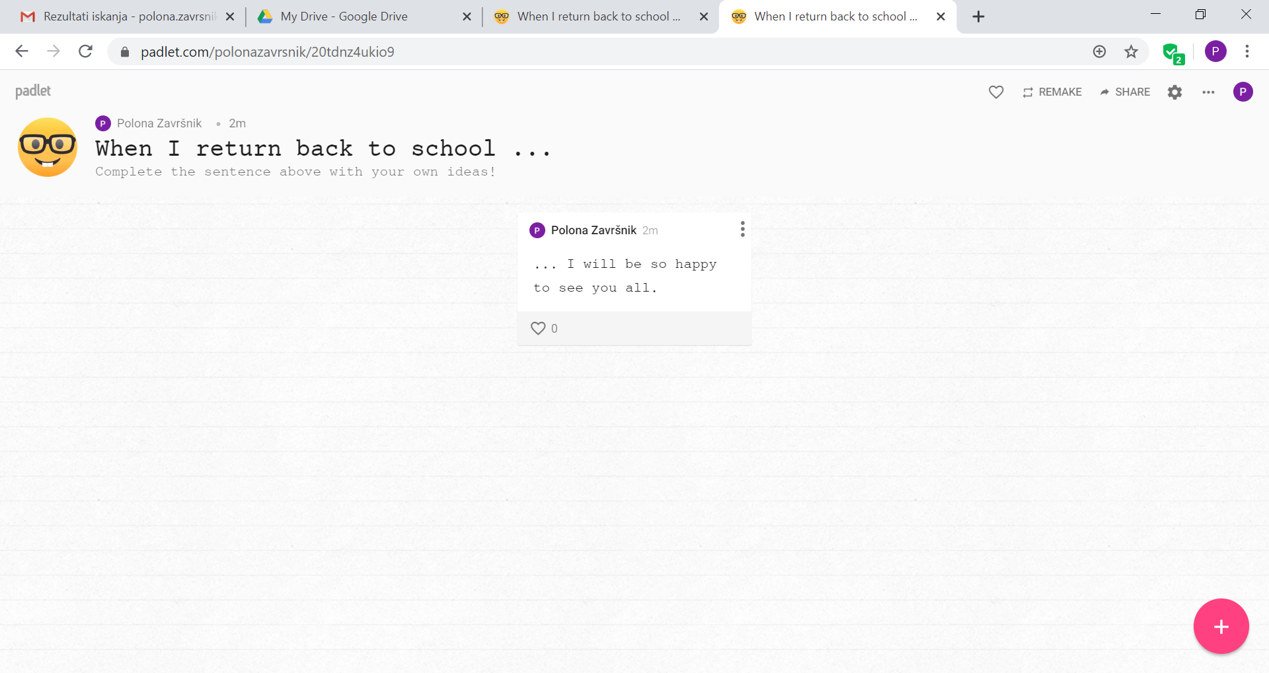
3.
2.
1.

Read the instructions!

Click on the pink icon to create a new post. You don’t need to be signed in to do it, but please do write your name on your post. Don’t forget to use English when you write! If you want to add pictures, links, videos that you want to share with us, just click the three dots and options will appear. When you are done, just click anywhere outside your post and voila – you have just posted something in our padlet! You can always come back and check what your classmates wrote by using the same link as before.

Now, open up your student’s book, page 70 and listen to the story We need a holiday! Use the link: https://elt.oup.com/student/project/?cc=si&selLanguage=en
When you are done, do exercises 1, 2 and 3.

Take your notebook and some coloured pencils and copy the text below into your notebook:

FUTURE TIME CLAUSES (ČASOVNI ODVISNIKI)

V njih podamo dodatno informacijo o tem, KDAJ bomo nekaj storili:
Ko pridem domov iz šole, bom pospravila sobo. – When I come back home from school, I will tidy my room.
Sestavljeni so:
- iz glavnega stavka (MAIN CLAUSE),
- odvisnega stavka (TIME CLAUSE), ki se vedno začne z besedicami WHEN, UNTIL, AFTER, AS SOON AS, WHILE, BEFORE ...
Za odvisnim stavkom vedno stoji vejica (When I come back home from school, I will tidy my room.)

As soon as I finish my homework, I will call my friend.
ODV. ST.: present simple GL. ST.: will + glagol

When you are done, click the link https://padlet.com/polonazavrsnik/20tdnz4ukio9
again and check what will your classmates do when they are back at school.

Keep up the good work, we are done for today!

THURSDAY, 26th March
Heeeeeeellloooooo from the other side,
this is your teacher writing to you … Today, do exercises 4, 5 and 6 in your SB’s and then take your workbook and do exercise 1 on page 66 and exercise 10 on page 68.

That’s it – no more exercises today! Stay well.
Teacher P.

FRIDAY, 27th March
https://www.youtube.com/watch?v=yE4ImieL6YA
If you feel like the girl in the clip, when it’s time to do some schoolwork, don’t worry, I completely understand! So, today’s first task is to find one song that you really like and play it on your phone (volume up) and dance to it like nobody is watching (boys, you too!).
When you are done dancing around your house, grab your workbook and open it up to page 56 and 57 – do all the exercises.
You can check your answers here:
https://www.mladinska.com/sola/center_oxford/resitve

Have a good weekend!

