9. 3. in 4. skupina
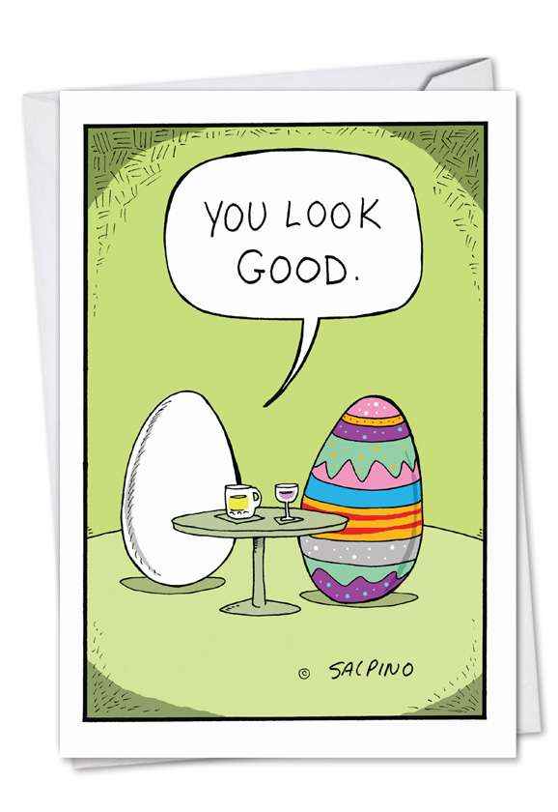
Wednesday, 8th April – Friday, 10th April

In this week, you will get familiar with some of the Slovenian customs during Easter period.
First, watch the clip about Easter customs around Europe:
https://www.youtube.com/watch?v=2DqyTAyaYag

Can you name some typical Slovenian customs that take place around Easter? Find some on the internet (if you are interested in the customs of some other countries, check those too).

What to do? You have two options (choose one):
- COLOUR SOME EGGS:
- Watch the clip: https://www.youtube.com/watch?v=s5Y52MRyfHs

- Write down all the ingredients (of course you don’t have to colour 10 or 20 eggs, because that’s a lot, you can start with 3 or 5 – you will also need less onion peels) and think of how and when are you going to dye the eggs.

- Make a plan and dye the eggs.

- Throughout the whole process, use English to communicate with your family members. If they think there is something wrong with you, tell them that I told you to do it!

- Send pictures of the process and eggs to polona.zavrsnik@os-franaerjavca.si

- You can also create a short video if you want to!
You have the whole week to do that (until next Wednseday).
- LEARN ABOUT ANOTHER EASTER CUSTOM:

- Search the internet for another Slovenian Easter custom, read all about it, get as much information as you can.

- Make a presentation about it - be funny, innovative, creative - you can make a mind map, poster, power point presentation, comic, a short film etc. – be creative and use your imagination!

- Throughout the whole process (when you are doing the task), use English to communicate with your family members. If they think there is something wrong with you, tell them that I told you to do it!

- Send your project to polona.zavrsnik@os-franaerjavca.si

You have the whole week to do that (until next Wednseday).

Because I know that you all work hard and I wanted to show you that I miss you, I am sending you a link to a short video I made. Hope you like it!
https://youtu.be/wN650hlRiQ4

Your teacher Polona

