**SPOZNAVANJE OKOLJA**

**slike za razgovor**

**SKRBIM ZA SVOJE ZDRAVJE**

1. **SKRBIM ZA OSEBNO ČISTOČO:**



1. **ZDRAVO SE PREHRANJUJEM:**

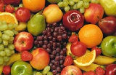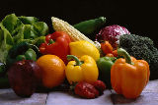

1. **VELIKO SE GIBAM NA SVEŽEM ZRAKU:**



1. **DOVOLJ SPIM:**



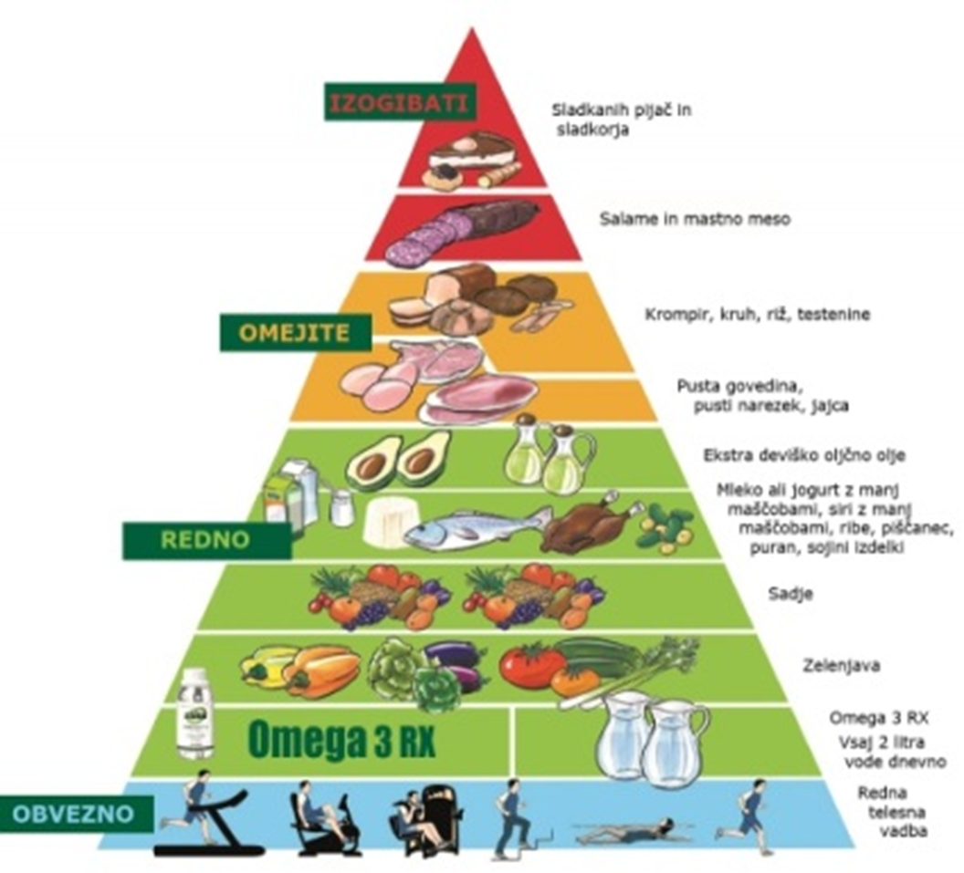

**ponedeljek, 6.4.2020; reši učni list in ga zalepi v brezčrtni zvezek**

**SKRBIM ZA ZDRAVJE**

|  |  |
| --- | --- |
| PIKTOGRAMI | **VSAK DAN V TEDNU OZNAČI, KAKO SI POSKRBEL-A ZA SVOJE ZDRAVJE.** |

|  |  |  |  |  |  |  |  |
| --- | --- | --- | --- | --- | --- | --- | --- |
| **☺** | **DOBRO** |  | **😐** | **ŠE KAR** |  | **☹** | **SLABO** |

|  |  |  |  |  |  |
| --- | --- | --- | --- | --- | --- |
|  | **ZDRAVA HRANA** | **DOVOLJ SPANJA** | **GIBANJE** | **UMIVANJE** | **UMIVANJE ZOB** |
| **PONEDELJEK** |  |  |  |  |  |
| **TOREK** |  |  |  |  |  |
| **SREDA** |  |  |  |  |  |
| **ČETRTEK** |  |  |  |  |  |
| **PETEK** |  |  |  |  |  |
| **SOBOTA** |  |  |  |  |  |
| **NEDELJA** |  |  |  |  |  |

**torek, 7.4.2020; reši učni list in ga zalepi v brezčrtni zvezek**

**ZDRAVA PREHRANA**

|  |  |
| --- | --- |
| PIKTOGRAMI | **Z ZELENO BARVICO OKROŽI ZDRAVO HRANO.**  **S SVINČNIKOM OBKROŽI TISTO HRANO, KI JO IMAŠ RAD-A.** |

|  |  |  |  |
| --- | --- | --- | --- |
| Apple Drawing Clip Art at Clker.com - vector clip art online ... | Coloring Book, Chocolate Bar Stock Vector - Illustration of black ... | Milk clipart carton Download PNG images for free | Welcome on TP ... | vegetables-different-kind-fruits-coloring_55094.jpg (600×395 ... |
| Cola clipart black and white » Clipart Station | Broccoli clipart black and white 1 » Clipart Station | Clip Art Fries Images, Stock Photos & Vectors | Shutterstock | 7,287 Lettuce Leaf Cliparts, Stock Vector And Royalty Free Lettuce ... |
| vegetables-different-kind-fruits-coloring_55094.jpg (600×395 ... | Drawing detail cupcake, Picture #1027438 drawing detail cake | Roasted chicken stock vector. Illustration of grill, bird - 34424943 | Christmas Candy Cane Coloring Pages at GetDrawings | Free download Candy icon cartoon black and white Royalty Free Vector Image |
| Amazon.com: Simple Black White Cheesy Pizza Cartoon Art Vinyl ... | Fruits Clipart Black And White | Free download on ClipArtMag | French Fries Illustration Royalty Free Cliparts, Vectors, And ... | A Real Belgian Cheese.The Dark Belgian Wolf. Belgium Single Icon ... |

**V VELIK BREZČRTNI ZVEZEK ZAPIŠI NASLOV:**

**SKRBIM ZA SVOJE ZDRAVJE**

NARIŠI NEKAJ PRIMEROV, KAKO SKRBIŠ ZA SVOJE ZDRAVJE.